# Custom Widgets

## Adding a custom widget to your account

To add your widget to your Jotform account, first head over to the widgets page on Jotform [Online Form Widgets | Jotform](https://www.jotform.com/widgets/) and from there do the following:

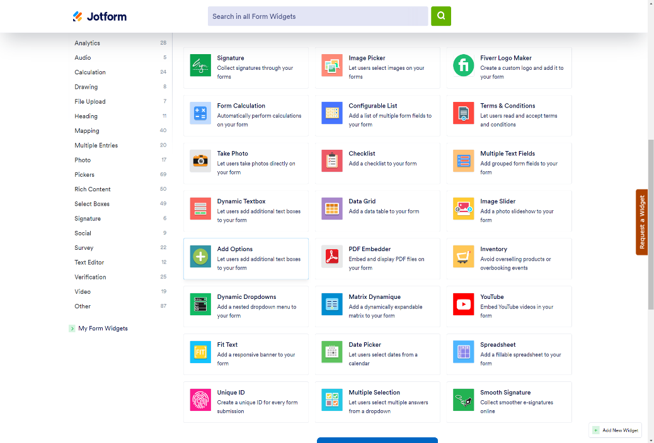

Once you’re at the widgets page click on **Add New Widget** this should bring up a new window (see next image).

Here you need to provide the following information for these mandatory fields:

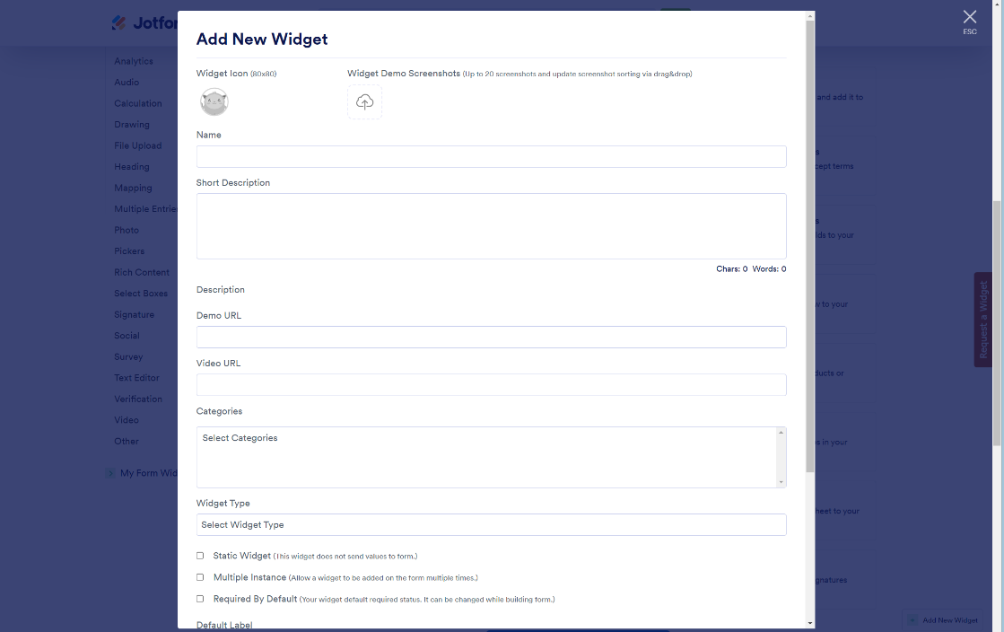

**Widget Demo Screenshot** (Can be any image)

**Name** (Must be a name that’s not in use)

**Short Description** (Can be anything)

**Categories** (Doesn’t affect the way your widget works)

**Widget Type** (The best option available is iFrame Widget once selected additional fields are added)

Selecting **iFrame Widget** should open more mandatory fields to fill in:

**Widget Width** (The default width of your widget)

**Widget Height** (The default height of your widget)

**Widget iFrame URL** (This should be the URL of where your widget is hosted)

**User Parameters** (If your widget takes in parameters you can access it using JFCustomWidget.getWidgetSettings() in your widget’s code)

The parameters for the images picker are as follows:

*Note - please make sure the* ***Name*** *is exactly the same as the one mentioned below*

|  |  |  |  |  |
| --- | --- | --- | --- | --- |
| **Name** | **Human Readable Name** | **Field Type** | **Default Value** | **Hint** |
| optionLabels | Option Labels | Textarea |  | (maximum 10) |
| fontSize | Font Size | Text |  |  |
| allowMultipleSelection | Allow Multiple Selection | Dropdown | No |  |

* For **allowMultipleSelection** the Dropdown Options should be ‘*Yes’* or ‘*No’*.

* *Note: Option should be on a new line.*

Once those fields are filled out you can click on the **Add** button. This should make your widget available for use in the form builder. Also, please note in order to get a custom widget added you enterprise account you must raise a support ticket to do so.